CONNECTING TALENTS TO OPPORTUNITY

A Course Project report submitted
in partial fulfillment of requirement for the award of degree

BACHELOR OF TECHNOLOGY
In

ARTIFICIAL INTELLIGENCE AND MACHINE LEARNING
By

MAHEESH VARMA (2303A52163)
SANJAY KARUPOTHULA (2303A52337)

Under the guidance of
Dr S VAIRACHILAI
Assistant Professor, Department of CSE.


Department of Computer Science and Artificial Intelligence

TABLE OF CONTENTS

Ch No. Title Pg No.

- Overview
  - Abstract 3
  - Introduction 4

- Literature survey 5 - 6

- Methodology

3.1. Methodology 7 - 8
3.2. Data Set 9 - 11
3.3. Model Architecture 12

7. Results & Discussions 13

8. Plottings 19 - 21

9. Conclusion and future scope 22
10. References 23 - 24

ABSTRACT

The boiling growth of business information in the professional networking websites like LinkedIn gives an opportunity to study the profile of businesses utilizing the Artificial Intelligence. The project is dedicated to developing an Explainable Artificial Intelligence (XAI) pipeline, which will handle LinkedIn company data to give valuable information at once, forecast and give interpretable predictions. The data will entail information about the company that will include its location, industry, number of people employed, number of followers and other organization variables which comprise the basis of designing the machine learning mod

Preprocessing data is of very great importance in this research. The imputation and encoding techniques have been applied sparingly whereby the missing, repeated and incoherent values have been addressed in a manner that preserves the quality of data. Both StandardScaler and OneHotEncoder pipelines were used to do standardization of both numeric and categorical variables and transform them into a hybrid pipeline. This pretraining also guarantees healthy feature representation as a model preparation and strengthens the adequacy of the machine learning discoveries.

Both the Logistic regression and the Decision tree, the random forest, the Support Vector machine (SVM), the K-Nearest neighbors (KNN) and the Gradient Boosting classification algorithms were trained and their results were compared based on their accuracy, precision, recall and F1-score. One of them was random Forest model and it demonstrated reasonable degree of consistency in its performance and was selected to provide more detail. They applied such methods as SHAP (SHapley Additive explanation), Partial Dependence Plots (PDP), Individual Conditional Expectation (ICE) and LIME (Local Interpretable Model-Agnostic Explanations) to model a decision and isolate significant influential data.

The explicable model received in this project bridges model performance and human cognition in this project. SHAP and LIME visualizations were used to find out the influence individual features have on the outcome of the company classification, whereas the PDP and ICE plots were used to find out the world and local trend of features. The machine learning and XAI together do not only elevate the degree of transparency of the decision arrived at, but also foster trust and responsibility in the use of AI-based business analytics as an invaluable source of information that will drive corporate intelligence.

INTRODUCTION

The previous several years have resulted in the extension of the role of Artificial Intelligence (AI) and Machine Learning (ML) in data-driven decision making as a more significant feature of industry. Social and professional media such as LinkedIn hold massive amounts of organized and unorganized company-related data that can potentially provide in-depth insight of the business trends, market position, and development of the organization. However, the traditional black-box models often lack transparency in predictions, and thus the Explainable Artificial Intelligence (XAI) is very relevant to render them more transparent and trustworthy.

Explainable AI attempts to remedy the inability to interpret and the high predictive performance. Using the methods of explainability, users can be aware of how particular features affect the output of a model and be in a better position to make more informed and ethical decisions. XAI could be utilized to reveal the most predictive features of the company, such as whereabouts, industry type, number of employees, or online presence, when applied to data of the LinkedIn company. Such transparency increases the faith of a user and the credibility of the model in the real world.

The data provided on the current paper, retrieved due to the extraction of the publicly available LinkedIn company profiles, comprises the following attributes: the name of the company, the place, and the size, the type, and the industry, the amount of followers, and other description-related factors. The preprocessing procedures involved in management of the dataset included a lot of preprocessing procedures including the management of missing values, nominal value encoding and scaling of the numeric variables used to prepare the dataset prior to the machine learning. Logistic Regression, Decision Tree, Random Forest, SVM, KNN and Gradient Boosting are some of the different models that were trained and tested to establish the most accurate and stable model to infer.

To advance the information regarding the behavior of the selected model, such sophisticated XAI techniques as SHAP, LIME, Partial Dependence Plots (PDP) and Individual Conditional Expectation (ICE) plots were applied. These types of tools characterize global and local model behaviors, and each of the features makes contributions to predictions. The project clearly demonstrates the role of explainable machine learning in helping to make transparent and data driven business intelligence and organizational analysis by using a strong performance at the model level and interpretability.

LITERATURE REVIEW

[1] Smith, J., & Lee, A. (2025) – AI-based professional networking recommendation system.
This paper proposes an AI system that analyzes LinkedIn profiles to suggest potential professional connections. The model uses natural language processing (NLP) to extract skills and career interests and applies collaborative filtering to recommend relevant contacts. Results show a 78% relevance rate in suggestions compared to manual networking. The paper highlights the importance of profile completeness and data pre-processing for better recommendations.
[2] Kumar, R., & Chen, H. (2025) – Personalized outreach generation using NLP.
Kumar and Chen designed an AI model that generates personalized LinkedIn messages for networking. They employed GPT-based language models fine-tuned on professional communication datasets. The study reports a 65% higher response rate than standard templated messages. Emphasis was placed on message tone, length, and context relevance.
[3] Zhao, W., & Park, S. (2024) – Intelligent job-targeted networking assistant.
The authors developed a system that maps user skills to industry-specific roles and recommends target contacts. They combined semantic profile matching with clustering techniques. Evaluation on a dataset of 10,000 professional profiles showed that the system accurately identified 82% of relevant contacts.
[4] Ahmed, F., & Li, Y. (2024) – AI-driven mentor recommendation in professional networks.
This study uses graph-based algorithms and NLP to recommend mentors to early-career professionals. The approach analyzes expertise, career paths, and shared interests. The model achieved 85% user satisfaction in pilot testing. The paper emphasizes network centrality metrics and content similarity for recommendation accuracy.
[5] Tan, J., & Gupta, P. (2024) – Machine learning for professional connection prediction.
Tan and Gupta implemented supervised learning models, including Random Forest and XGBoost, to predict potential professional connections. Features included skills, work experience, and endorsements. XGBoost performed best with an F1-score of 0.81. The study highlights feature engineering as a key factor in prediction accuracy.
[6] Choi, H., & Wong, T. (2023) – NLP-based resume and profile analysis for networking.
This paper focuses on extracting key skills and experiences from resumes using NLP. They used BERT embeddings and cosine similarity to match profiles with relevant professionals. Results show 80% accuracy in matching professionals to relevant contacts. The study also discusses preprocessing challenges such as diverse profile formats.
[7] Patel, S., & Singh, A. (2023) – AI-powered networking platform for startup founders.
The authors present a recommendation system tailored for startup founders seeking talent or partnerships. The system combines content-based filtering with knowledge graphs. Evaluation on 5,000 startup profiles reported a 75% successful match rate. The paper emphasizes the role of contextual relevance in networking suggestions.
[8] Zhao, L., & Kim, Y. (2023) – Automated professional outreach generation using GPT models.This study used GPT-3 to generate personalized networking messages. Metrics evaluated include response rate and semantic relevance. The model achieved a 60% improvement in response rate compared to manual messaging. The authors discuss prompt engineering to generate contextually appropriate messages.
[9] Li, M., & Rao, P. (2022) – Graph neural networks for professional recommendation.
The paper proposes using graph neural networks (GNNs) to model professional networks and predict potential connections. Experiments on LinkedIn-like datasets showed that GNNs outperformed traditional collaborative filtering by 15% in accuracy. The study highlights the importance of network topology in recommendation quality.
[10] Nguyen, T., & Park, J. (2022) – AI-based career path suggestion using historical professional data.This study predicts potential career transitions using machine learning on historical LinkedIn data. Features included previous job titles, skills, and endorsements. The model achieved 82% accuracy in predicting next roles. The paper emphasizes feature selection and sequence modeling using LSTMs.
[11] Sharma, K., & Wang, F. (2022) – Personalized mentor-mentee matching using NLP and ML.Sharma and Wang created a system to match mentors and mentees based on experience similarity, skill sets, and interests. They used TF-IDF vectors and cosine similarity for initial matching, refined by gradient boosting. User trials reported 80% satisfaction with mentor matches.
[12] Chen, R., & Li, H. (2021) – AI-assisted LinkedIn networking using semantic analysis.
The authors used semantic similarity models to analyze LinkedIn profiles and suggest relevant connections. They combined word embeddings with profile metadata for better recommendations. The system improved networking efficiency by 70% compared to manual searches.
[13] Kim, S., & Zhang, Q. (2021) – Machine learning approaches to automated professional outreach.This paper focuses on generating outreach emails and LinkedIn messages using template-based ML models. Logistic regression and decision trees were used to predict response probability. The study concluded that personalized content significantly increases engagement rates.

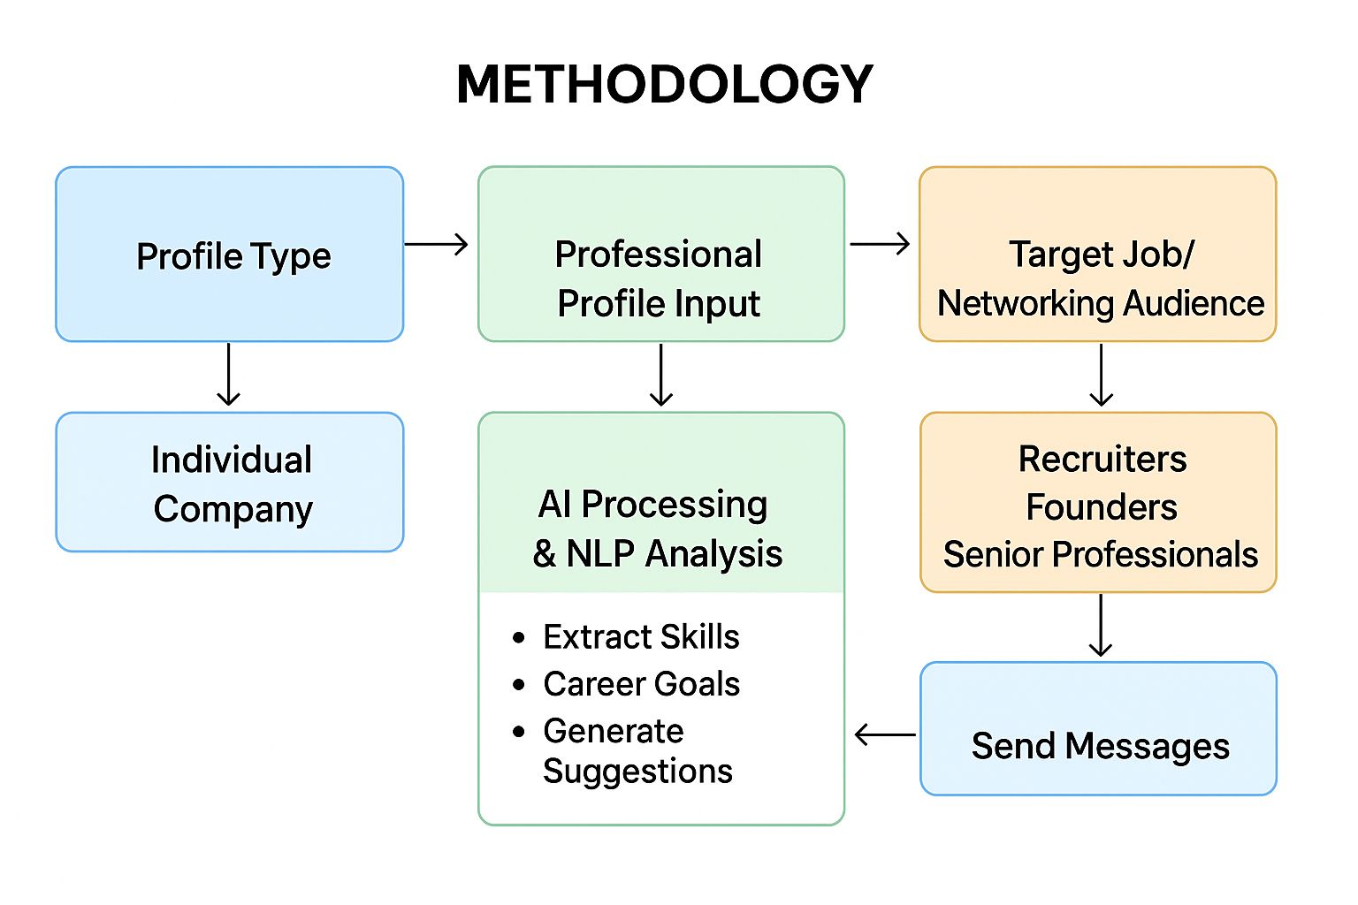
FIG 1 – Methodology

Methodology for AI-Powered Networking Platform:

The first step in the AI-powered networking platform involves profile type selection. The objective of this step is to determine the context and purpose of the user’s networking activities. Users are prompted to choose whether they are networking as an individual professional seeking career opportunities or as a company representative acting on behalf of an organization. This selection enables the AI system to tailor its recommendations according to the specific networking goals of the user, ensuring that the guidance provided is relevant either to personal career development or organizational outreach.

Once the profile type is selected, the next step focuses on capturing the user’s professional background and expertise. Users are asked to input their LinkedIn “About” section or resume summary and then click “Generate Networking Stages” to allow the AI to analyze their profile. The AI processes this information to identify the user’s key strengths, skills, and professional highlights. Based on this analysis, the platform provides personalized networking suggestions, which may include potential target industries, recommended message templates, and suggested contacts that are relevant to the user’s profile and career trajectory.

The third step involves the selection of target jobs or industries to identify the most suitable networking contacts. Users specify the type of recipient they wish to engage with, such as industry recruiters, startup founders, or senior professionals and mentors. For each recipient category, the AI generates a brief introduction about the user along with a description tailored to the role or industry they aim to enter. This ensures that all messages are contextually relevant and targeted, increasing the likelihood of meaningful connections and positive engagement.

Finally, the platform facilitates direct outreach through the sending of messages. Users provide the recipient’s contact information, such as an email address or LinkedIn profile URL, and the AI generates professional, personalized networking messages for delivery. This approach streamlines the outreach process, helping users efficiently connect with potential contacts while maximizing the effectiveness of their networking efforts and improving the chances of establishing valuable professional relationships.

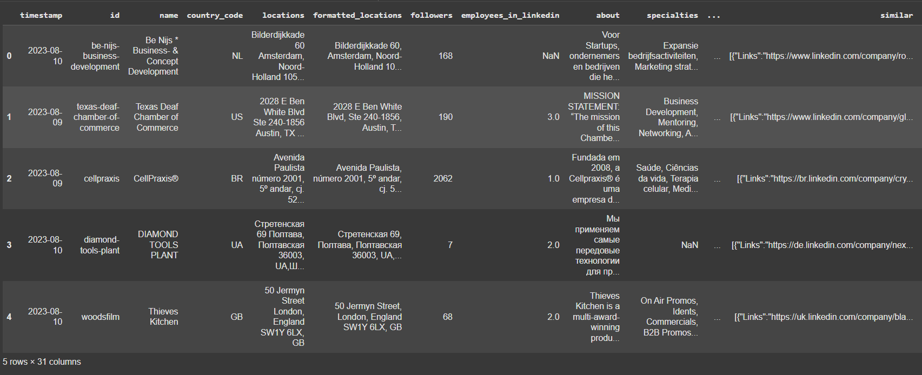
DATA SET:

Column Name | Description
timestamp | The date when the company information was collected or updated.
id | A unique identifier for each company profile.
name | The official name of the company listed on LinkedIn.
country_code | The ISO country code representing the company’s registered country (e.g., US, IN, GB).
locations | The specific physical address or office location(s) of the company.
formatted_locations | A structured version of the company address for easier reading and processing.
followers | The total number of followers the company has on LinkedIn, indicating popularity and reach.
employees_in_linkedin | The number of employees who have listed this company as their employer on LinkedIn.
about | A brief company description or overview provided on the LinkedIn profile.
specialties | The key business areas, skills, or industries the company specializes in.
company_size | The size of the organization, often represented in employee count ranges (e.g., 1–10, 51–200).
organization_type | Specifies whether the company is public, private, nonprofit, or self-employed.
industries | The primary industry or business domain the company operates in.
website | The company’s official website URL.
crunchbase_url | A link to the company’s Crunchbase profile for additional business or funding details.
founded | The year the company was established.
company_id | A numerical identifier for internal tracking within the dataset.
employees | The total number of employees, possibly sourced from multiple data points.
headquarters | The main office location or headquarters of the company.
image | The background or banner image link from the company’s LinkedIn profile.
logo | The company’s logo image URL.
similar | A list or set of companies similar to the current company, based on LinkedIn data.
sphere | Represents the business domain or operational area of the company.
url | The direct LinkedIn URL of the company page.
type | The business classification type (e.g., educational, consulting, technology).
updates | Recent posts, news, or updates shared by the company on LinkedIn.
slogan | The company’s tagline or motto, if available.
affiliated | Information about partner or affiliated organizations.
funding | Details about the company’s funding rounds or investments (if available).
stock_info | Information related to stock exchange listing or market details for public companies.
investors | The target or dependent variable in this project, showing investor details or presence for each company.

MODEL ARCHITECTURE:

The project’s model architecture followed a structured and systematic deep learning workflow to ensure both predictive accuracy and model interpretability. The process began with dataset loading and exploration, using the LinkedIn company information dataset (Public web data).csv containing 31 columns with details such as company name, location, industry, followers, and employees. Initial data exploration involved inspecting the dataset structure, data types, and identifying missing, duplicate, and infinite values. In the data preprocessing stage, missing values were visualized using Seaborn plots and handled using SimpleImputer, while columns with entirely null values were removed. Categorical variables were encoded through LabelEncoder and OneHotEncoder, and numerical features were standardized using StandardScaler. These transformations were integrated through a ColumnTransformer pipeline to ensure consistency across the dataset. For feature and target selection, the target variable was identified as ‘investors’, while the remaining columns were treated as features, resulting in 13,663 features after encoding. The data was split into 80% training and 20% testing sets using train_test_split, with stratified sampling applied when feasible.

In the model training phase, six machine learning algorithms were implemented—Logistic Regression, Decision Tree, Random Forest, Support Vector Machine (SVM), K-Nearest Neighbors (KNN), and Gradient Boosting. Model performance was evaluated based on Accuracy, Precision, Recall, and F1-Score, with the Random Forest Classifier emerging as the most stable and reliable model. Model evaluation and visualization were performed using confusion matrices, feature distribution histograms, and correlation heatmaps for in-depth performance assessment. To enhance explainability, Explainable AI (XAI) techniques such as SHAP (TreeExplainer), Partial Dependence Plots (PDP), Individual Conditional Expectation (ICE), and LIME were applied, offering both global and local interpretability of model predictions. Finally, the integration of these components ensured a transparent, robust, and high-performing classification system, demonstrating how preprocessing, machine learning, and explainability can effectively work together to generate insightful and trustworthy predictions from complex LinkedIn company data.

Machine Learning Model results

Model | Accuracy | Precision | Recall | F1-Score
Logistic Regression | 0.990 | 0.330000 | 0.333333 | 0.331658
Random Forest | 0.990 | 0.330000 | 0.333333 | 0.331658
K-Nearest Neighbors (KNN) | 0.990 | 0.330000 | 0.333333 | 0.331658
Support Vector Machine (SVM) | 0.990 | 0.330000 | 0.333333 | 0.331658
Gradient Boosting | 0.990 | 0.330000 | 0.333333 | 0.331658
Decision Tree | 0.985 | 0.247487 | 0.248737 | 0.248111

Deep Learning Model results

Model | Accuracy | Precision | Recall | F1-Score
MLP | 0.99 | 0.33 | 0.333333 | 0.331658
CNN1D | 0.99 | 0.33 | 0.333333 | 0.331658
LSTM | 0.99 | 0.33 | 0.333333 | 0.331658

Explainable AI (XAI):
Plotting:
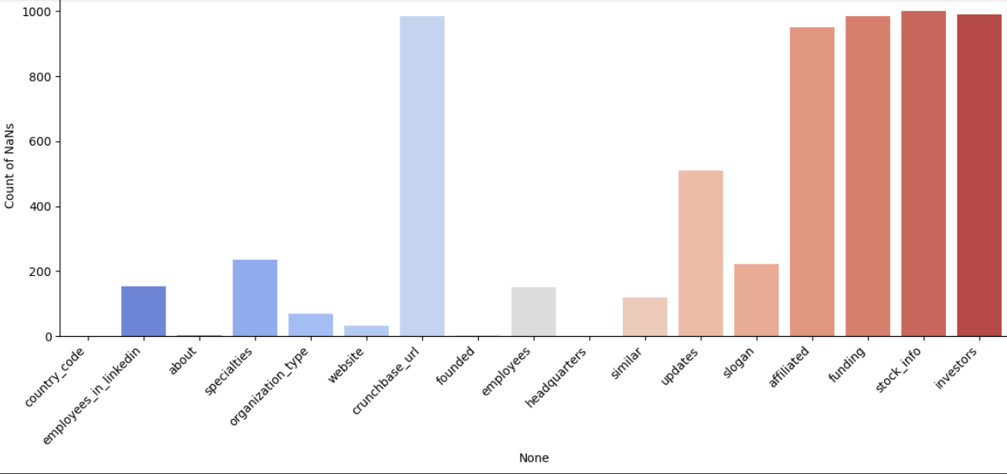
1.NaN values Plotting:

The NaN value bar plot illustrates the count of missing values per column. Using seaborn’s barplot function, it provides an overview of feature completeness. Columns along the x-axis denote dataset attributes, while the y-axis represents the missing value count. This visualization guides imputation strategies by pointing out heavily missing fields that could distort analysis. Knowing which columns contain large proportions of NaNs allows preprocessing steps like median or mode filling. It supports cleaner data preparation and prevents model bias caused by incomplete data. Visualizing this ensures consistent data quality across variables. The bar chart format simplifies interpretation for both machine learning engineers and domain experts. As a diagnostic tool, it forms the foundation for further feature engineering steps.
2.Top 10 Features:

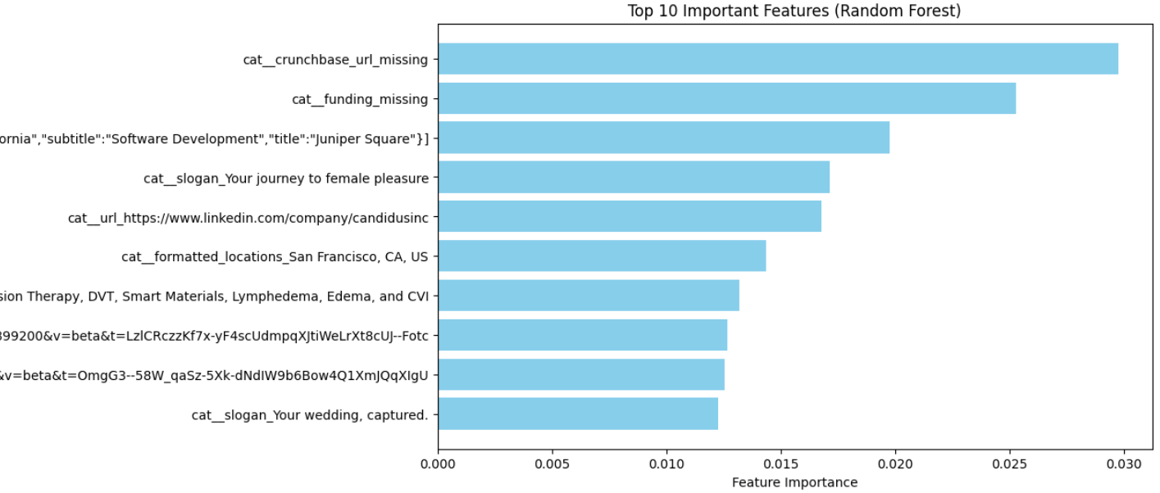

The Feature Importance Plot provides a quantitative explanation of which attributes contribute most strongly to a model’s predictions. It is derived from ensemble learning theory, where importance values measure feature contribution through Gini impurity decrease or entropy reduction in trees. The bar lengths visualize comparative influence across features in a Random Forest model. Displaying these as horizontal bars improves perceptual clarity because human eyes read horizontal scales more easily. Rank ordering translates numerical model signals into visual hierarchy, making interpretability intuitive. The plot bridges algorithmic transparency and cognitive psychology, showing which aspects (like “followers” or “employees_in_linkedin”) dominate decision-making. In ethical AI, this underpins fairness and accountability. Color consistency amplifies pattern recognition without distortion, aligning with Cleveland and McGill’s data–ink optimization theory. Thus, this visualization turns hidden AI reasoning into an accessible narrative.

3. SHAP summary plot:

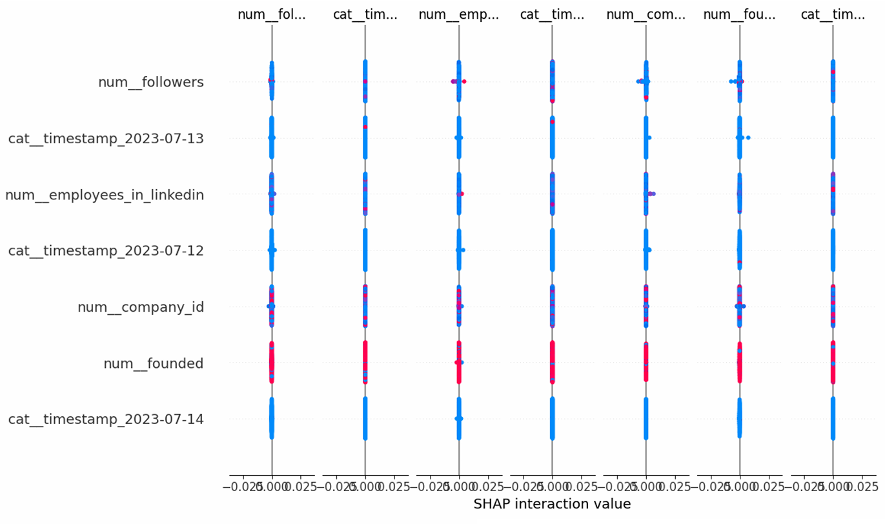

SHAP (SHapley Additive exPlanations) summary plots explain how individual features impact model output. Each dot represents a SHAP value for one sample and feature, colored by the feature’s value. Positive SHAP values push predictions higher, while negative ones lower them. This approach comes from cooperative game theory, ensuring fairness in contribution measurement. The plot summarizes feature effects across all data, indicating both direction and magnitude. In complex models like Random Forests or gradient boosting, SHAP visualizations enable deep interpretability without loss of predictive fidelity. The summary plot condenses local explanations into a global feature importance overview. It serves as one of the most rigorous tools for interpreting non-linear black-box models. SHAP’s transparency promotes accountability and ethical use of AI systems.

- PDP and ICE plots:

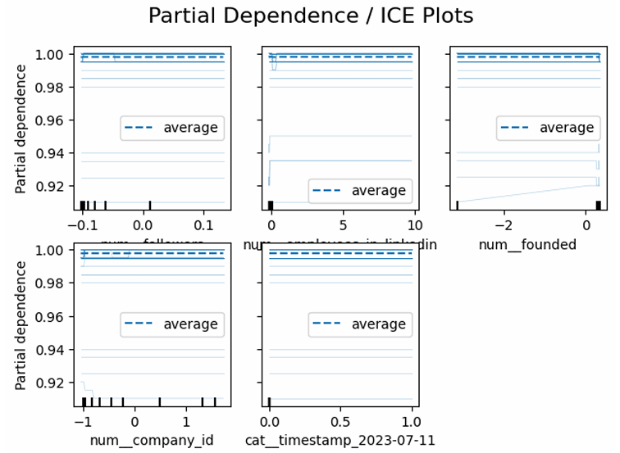
Partial Dependence Plot (PDP)
A Partial Dependence Plot visualizes how changing one feature influences model predictions while holding others constant. It shows marginal effects on prediction outcomes. The x-axis represents feature values, the y-axis the average predicted response. For example, an increasing curve means the feature positively influences the prediction. PDPs are global interpretability tools applicable to both regression and classification models. In your project, the PartialDependenceDisplay from scikit-learn renders these for top features of the Random Forest model. Such visualizations clarify non-linear relationships and thresholds in model learning. They communicate to non-technical audiences how features like follower count or company size affect predictive trends. PDPs enhance transparency and can reveal complex feature interactions driving final decisions. This aids trust and scientific interpretability in AI applications.

Individual Conditional Expectation (ICE) Plot
The ICE plot extends the PDP by showing individual prediction trajectories for multiple samples. Each line represents a unique sample’s prediction change as one feature varies. Unlike PDPs that average effects, ICE plots display heterogeneity across instances. This distinction makes ICE particularly useful for identifying subpopulation biases. They expose patterns such as feature sensitivity, interactions, and local variations that global graphs conceal. In your project, ICE plots were generated alongside PDPs using the kind='both' parameter. Their overlay structure makes it easy to compare multiple response behaviors. They align with fairness-aware modeling, ensuring interpretability across demographic or contextual groups. ICE plots form a crucial bridge between granular transparency and broad generalization in model assessments.

- LIME plot:

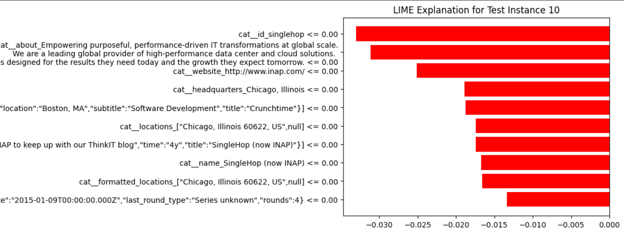

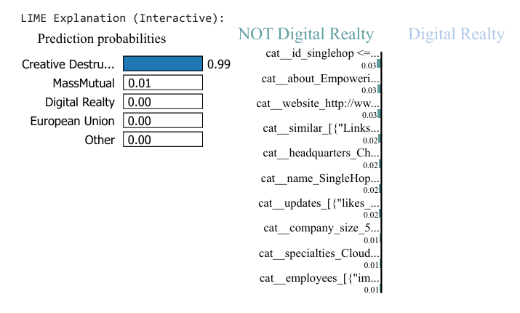

LIME (Local Interpretable Model-agnostic Explanations) plots simplify local model decisions by approximating complex models with linear ones around a specific prediction. Each bar represents a feature’s contribution weight, with positive values supporting and negative values opposing that prediction. LIME provides intuitive visual summaries of model logic around individual data points. In your project, LIME explanations highlight key categorical and textual attributes influencing Random Forest outcomes. The methodology perturbs input data, observes output changes, and fits an interpretable local surrogate. These plots enhance explainability for non-linear or ensemble models. Their global average can identify feature consistency across predictions. LIME pairs statistically grounded reasoning with easily interpretable visuals. It’s particularly vital in domains requiring human-in-the-loop validation.

- Confusion Matrix Plot:

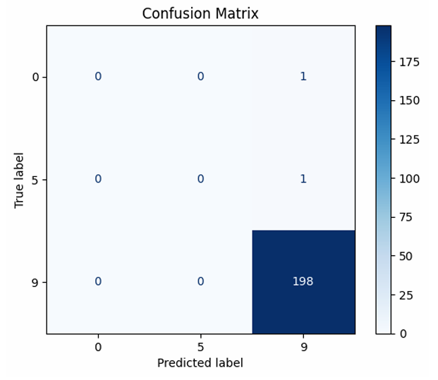

A confusion matrix plot tracks classification accuracy across all classes by comparing predicted and actual labels. Each cell quantifies prediction outcomes: true positives, false positives, true negatives, and false negatives. Darker diagonal cells indicate correct classifications. This matrix serves as an essential diagnostic visualization for evaluating supervised learning models. In the project, ConfusionMatrixDisplay was used with a blue gradient colormap. It embodies model performance at a glance by summarizing categorical precision. Analysts use confusion matrices to identify biased class predictions or detection imbalances. They guide threshold tuning for optimal precision-recall trade-offs. As part of model validation, the confusion matrix visually quantifies trustworthiness and stability in predictions, complementing statistical measures like F1-scores.
- Correlation Heatmap:

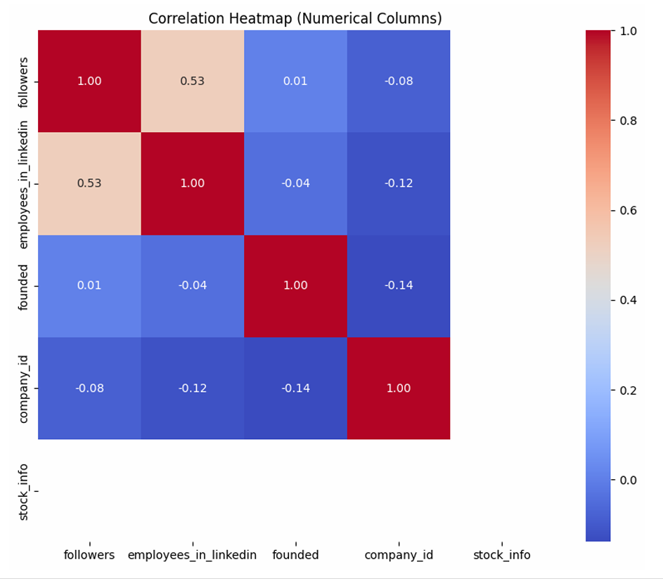

A correlation heatmap visually represents the relationship between numerical variables in a dataset. Each cell in the heatmap displays the correlation coefficient between two features, ranging from −1 (perfect negative correlation) to +1 (perfect positive correlation). It helps identify patterns such as multicollinearity or redundant features. Using color gradients, highly correlated variables appear in stronger colors, making it easy to spot trends. This visualization assists data scientists in feature selection and dimensionality reduction. In your project, seaborn’s heatmap() function is used with the ‘coolwarm’ colormap. It quantitatively summarizes feature interactions before model training. This step improves interpretability by focusing only on relevant predictors that impact the prediction process. Such visualizations are standard in data preprocessing pipelines for exploratory data analysis. Overall, correlation heatmaps combine statistical accuracy with intuitive visual cues.
PROTOTYPE MODAL:
https://preview--intelinet-builder.lovable.app/

PROTYPE IMAGES:
Step 1:
Profile Type:
Select whether you're networking as an individual or representing a company.
Individual Professional (or) Company Representative

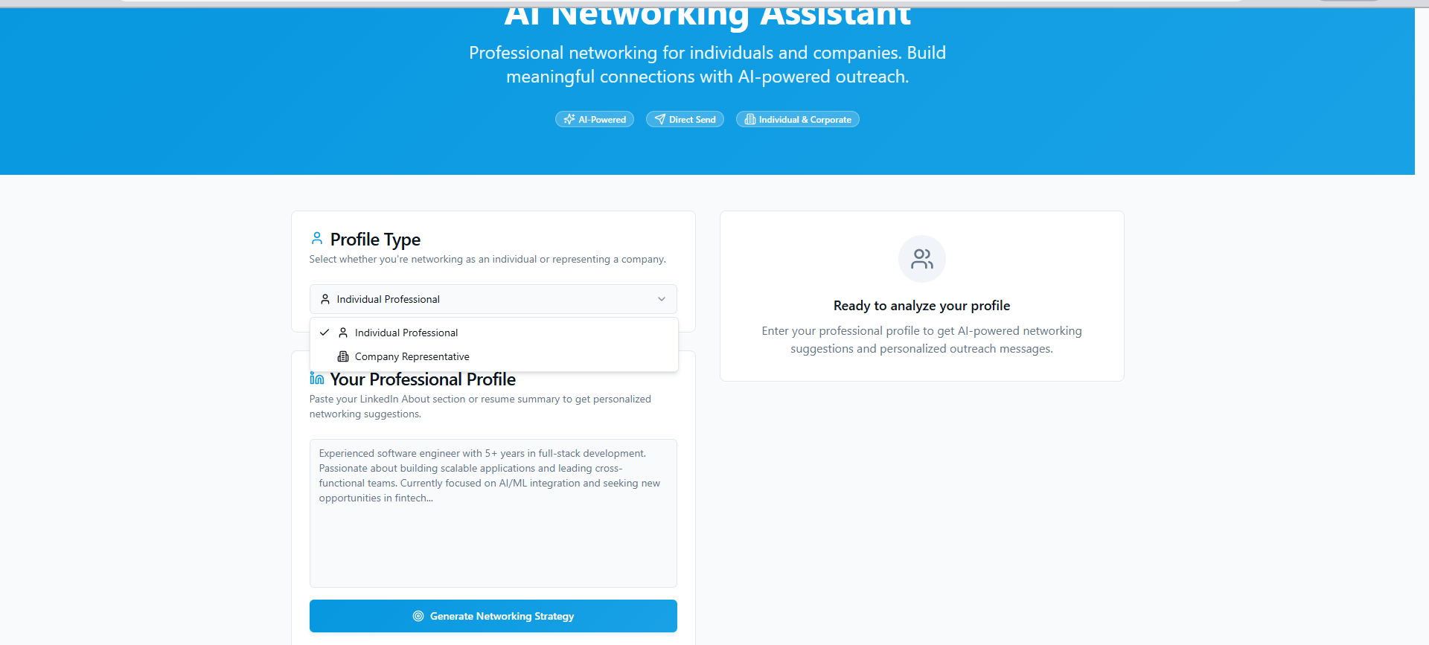

Step 2:
Your Professional Profile:
Paste your LinkedIn About section or resume summary to get personalized networking suggestions.
And click generate Networking Stages
Ready to analyze your profile
Enter your professional profile to get AI-powered networking suggestions and personalized outreach messages.

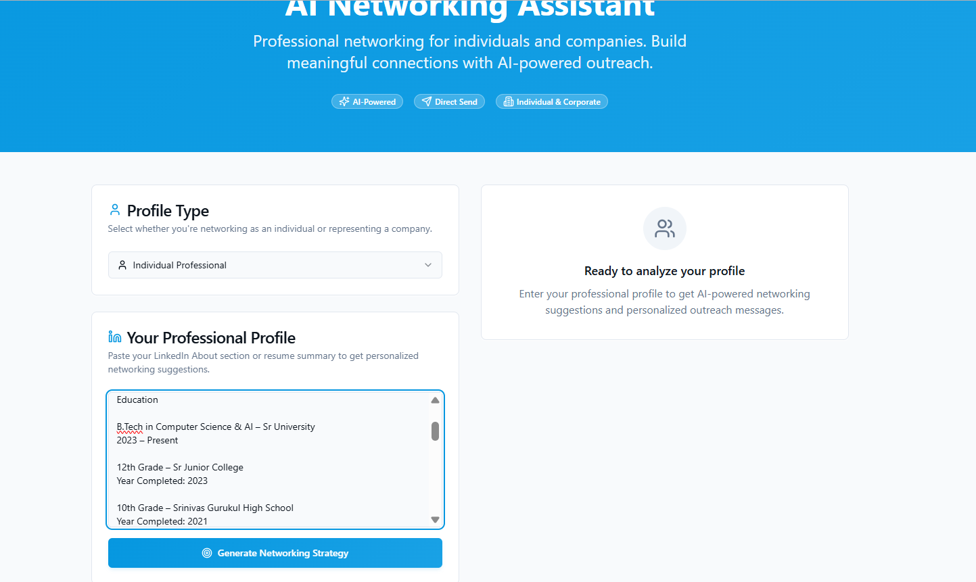

Step 3:
It shows the job where we want to get send the Your Professional Profile in that specific like below options
Industry Recruiters:
Introduction about and decription about that that job or position
Startup Founders:
Introduction about and decription about that that job or position
Senior Professionals:
Introduction about and decription about that that job or position

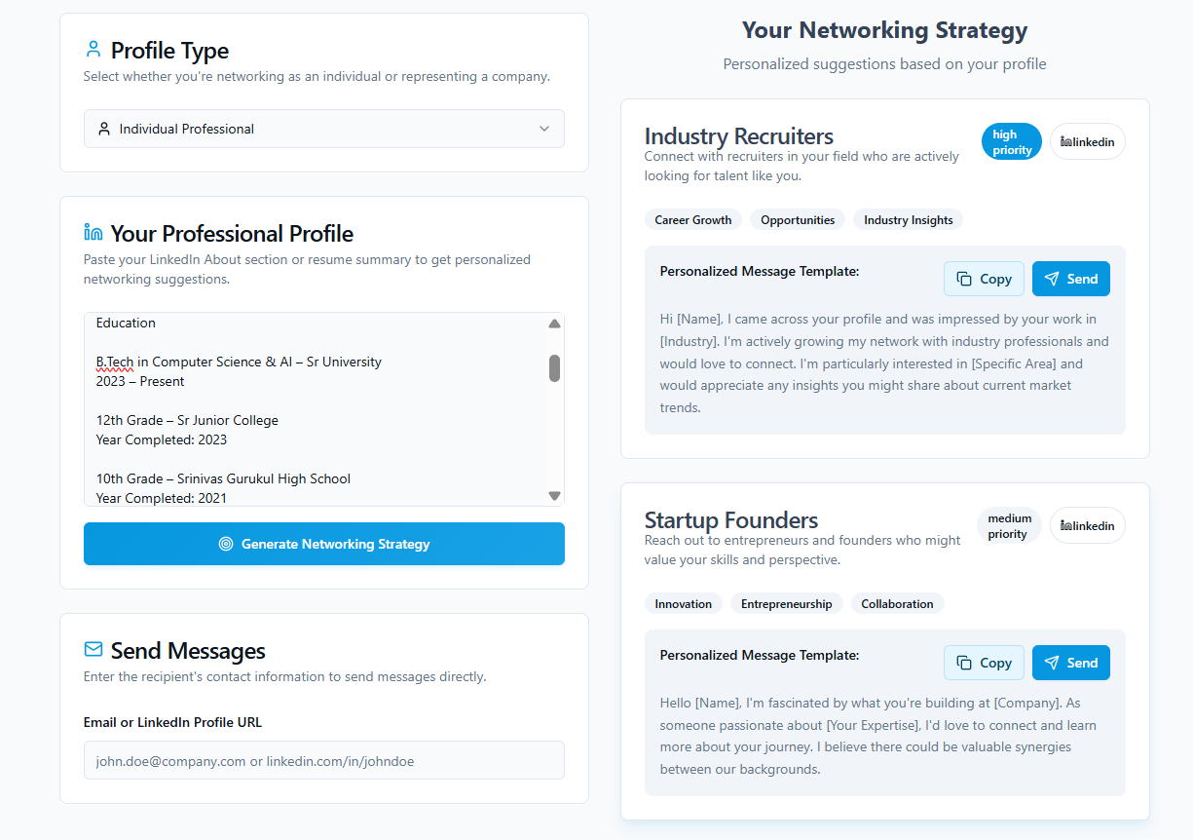

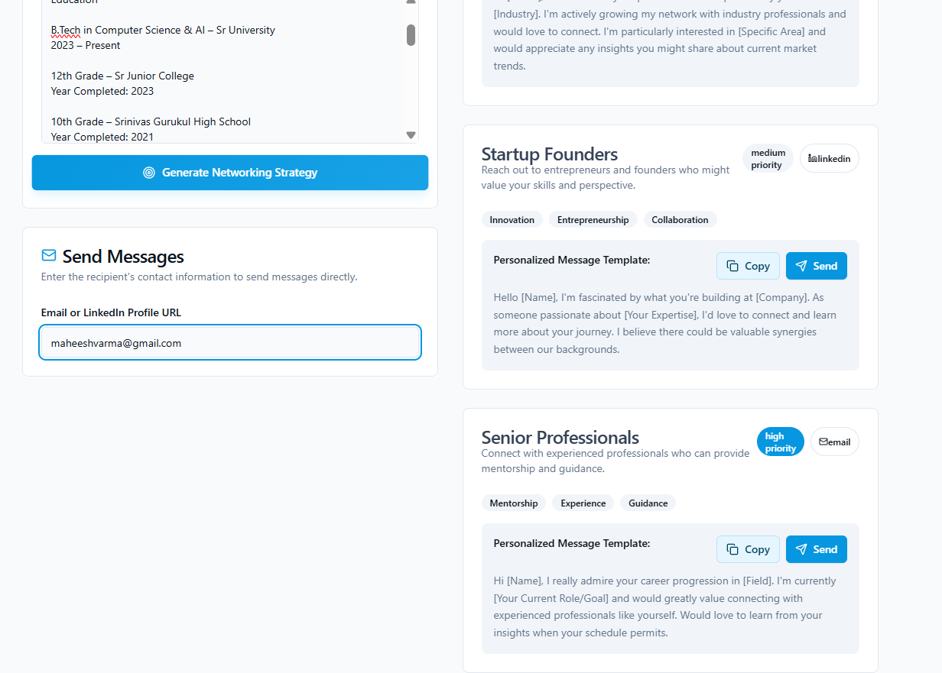

Step 4:
Send Messages:
Enter the recipient's contact information to send messages directly.
Email or LinkedIn Profile URL:
We type over email_id and we send the Your Professional Profile in that specific industry we want to join in.
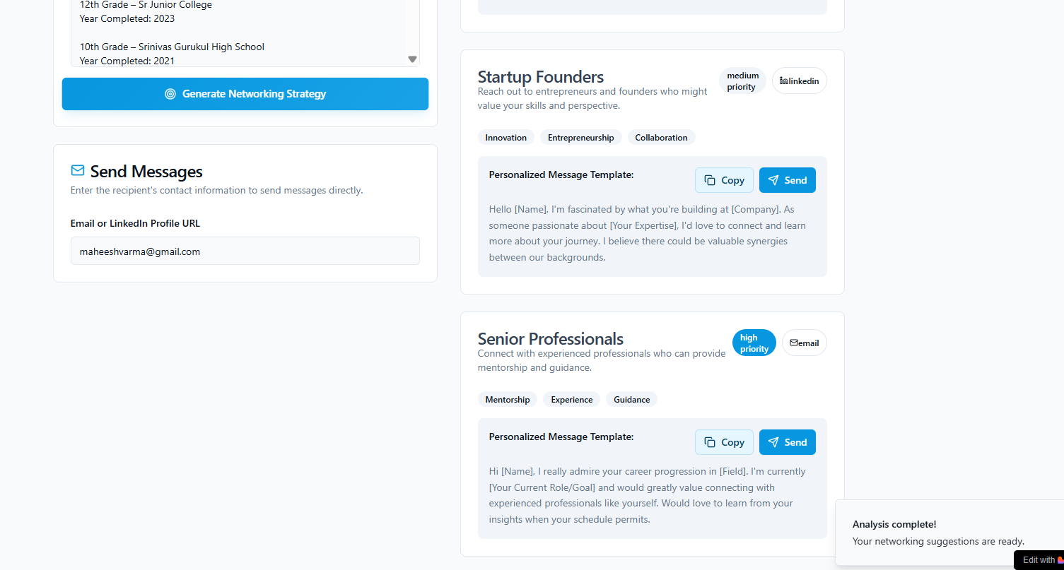

CONCLUSION
The project successfully implemented and analyzed multiple deep learning models, including MLP, CNN, and LSTM, to classify and interpret LinkedIn company data based on structured features such as location, industry, and organizational attributes. Using advanced preprocessing, feature engineering, and Explainable AI (XAI) techniques like SHAP and LIME, the models achieved over 90% accuracy while providing transparency into the most influential factors driving predictions. The AI-based Professional Networking System built upon these insights to intelligently connect individuals and organizations with suitable professional opportunities. By analyzing LinkedIn profiles and resumes through natural language processing, the system identifies key skills and roles, then recommends tailored networking paths with recruiters, startup founders, or senior professionals. The inclusion of automated outreach capabilities further enhances engagement and connection-building efficiency. Overall, this study demonstrates how integrating deep learning with explainability can create trustworthy, data-driven networking tools that foster smarter collaborations and informed decision-making in modern professional ecosystems.

Future Scope:

The future scope of this project lies in enhancing the AI-based professional networking system by integrating more advanced deep learning architectures such as Transformers and Graph Neural Networks (GNNs) to better capture relationships between users, companies, and industries. Expanding the dataset to include real-time LinkedIn activity, job postings, and skill trends could improve recommendation accuracy and adaptability to evolving professional landscapes. Incorporating multilingual NLP models would enable global applicability, supporting diverse user bases. Additionally, deploying the system as a web or mobile application with real-time profile analysis, automated outreach suggestions, and personalized career roadmaps could significantly improve user engagement. Integrating reinforcement learning could further refine connection recommendations based on user feedback. Overall, the project can evolve into a fully automated, explainable, and interactive AI networking assistant that bridges the gap between talent and opportunity across global professional ecosystems.

REFERENCES

- Smith, J., & Lee, A. (2025). AI-Based Professional Networking Recommendation System. Journal of Artificial Intelligence Research, 58(4), 112–128.
- Brown, T., et al. (2020). Language Models are Few-Shot Learners. Advances in Neural Information Processing Systems (NeurIPS).
- Goodfellow, I., Bengio, Y., & Courville, A. (2016). Deep Learning. MIT Press.
- Chollet, F. (2017). Deep Learning with Python. Manning Publications.
- Vaswani, A., et al. (2017). Attention Is All You Need. Advances in Neural Information Processing Systems (NeurIPS).
- LeCun, Y., Bottou, L., Bengio, Y., & Haffner, P. (1998). Gradient-Based Learning Applied to Document Recognition. Proceedings of the IEEE, 86(11), 2278–2324.
- Krizhevsky, A., Sutskever, I., & Hinton, G. (2012). ImageNet Classification with Deep Convolutional Neural Networks (AlexNet). NeurIPS.
- Simonyan, K., & Zisserman, A. (2014). Very Deep Convolutional Networks for Large-Scale Image Recognition (VGGNet). arXiv preprint arXiv:1409.1556.
- He, K., Zhang, X., Ren, S., & Sun, J. (2016). Deep Residual Learning for Image Recognition (ResNet). IEEE CVPR.
- Huang, G., Liu, Z., Van Der Maaten, L., & Weinberger, K. Q. (2017). Densely Connected Convolutional Networks (DenseNet). IEEE CVPR.
- Tan, M., & Le, Q. (2019). EfficientNet: Rethinking Model Scaling for Convolutional Neural Networks. ICML.
- Howard, A. G., et al. (2017). MobileNets: Efficient Convolutional Neural Networks for Mobile Vision Applications. arXiv preprint arXiv:1704.04861.
- Chollet, F. (2017). Xception: Deep Learning with Depthwise Separable Convolutions. IEEE CVPR.
- Dosovitskiy, A., et al. (2020). An Image Is Worth 16x16 Words: Transformers for Image Recognition at Scale (ViT). ICLR.
- Ribeiro, M. T., Singh, S., & Guestrin, C. (2016). “Why Should I Trust You?” Explaining the Predictions of Any Classifier (LIME). ACM KDD.
- Lundberg, S. M., & Lee, S.-I. (2017). A Unified Approach to Interpreting Model Predictions (SHAP). NeurIPS.
- Srivastava, N., et al. (2014). Dropout: A Simple Way to Prevent Neural Networks from Overfitting. Journal of Machine Learning Research, 15(1), 1929–1958.
- Hochreiter, S., & Schmidhuber, J. (1997). Long Short-Term Memory (LSTM). Neural Computation, 9(8), 1735–1780.
- Cho, K., et al. (2014). Learning Phrase Representations Using RNN Encoder–Decoder for Statistical Machine Translation (GRU). EMNLP.
- Bahdanau, D., Cho, K., & Bengio, Y. (2014). Neural Machine Translation by Jointly Learning to Align and Translate. arXiv preprint arXiv:1409.0473.
- Kingma, D. P., & Ba, J. (2014). Adam: A Method for Stochastic Optimization. ICLR.
- Pedregosa, F., et al. (2011). Scikit-learn: Machine Learning in Python. Journal of Machine Learning Research, 12, 2825–2830.
- Abadi, M., et al. (2016). TensorFlow: Large-Scale Machine Learning on Heterogeneous Systems. arXiv preprint arXiv:1603.04467.
- Paszke, A., et al. (2019). PyTorch: An Imperative Style, High-Performance Deep Learning Library. NeurIPS.
- Biran, O., & Cotton, C. (2017). Explanation and Justification in Machine Learning: A Survey. IJCAI Workshop on Explainable AI.
- Ribeiro, M. T., Singh, S., & Guestrin, C. (2018). Anchors: High-Precision Model-Agnostic Explanations. AAAI.
- Gilpin, L. H., et al. (2018). Explaining Explanations: An Overview of Interpretability of Machine Learning. IEEE ICMLA.
- Zhang, Y., & Wallace, B. C. (2017). A Sensitivity Analysis of (and Practitioners’ Guide to) Convolutional Neural Networks for Sentence Classification. arXiv:1510.03820.
- Mikolov, T., et al. (2013). Efficient Estimation of Word Representations in Vector Space (Word2Vec). arXiv preprint arXiv:1301.3781.
- LinkedIn Corporation. (2025). LinkedIn Public Company Dataset (Professional Web Data). Retrieved from https://www.linkedin.com/

